**First Request**

1/03/2024 Compiled clarification requested

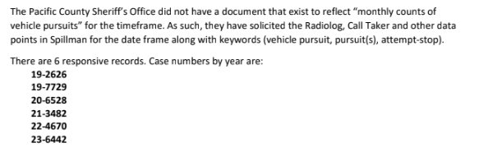

1/05/2024 Fulfilled no cost

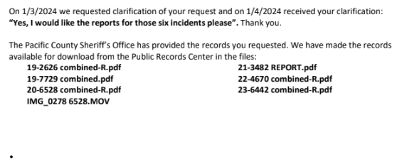

2/13/2024 1st

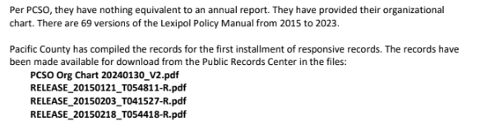

2/29/2024 2nd

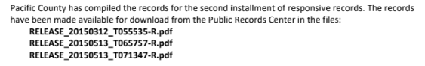

3/08/2024 3rd

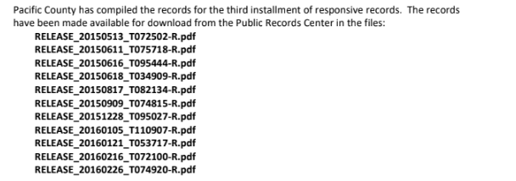

3/19/2024 4th

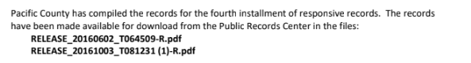

4/12/2024 5th

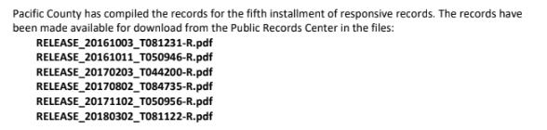

5/14/2024 6th

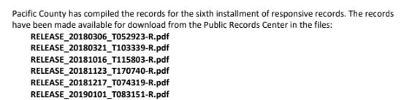

6/21/2024 7th

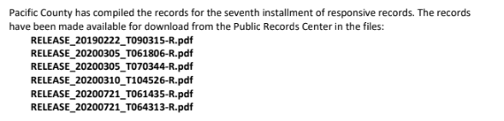

7/16/2024 8th

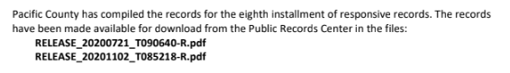

**Second request**

8/01/2024 1st

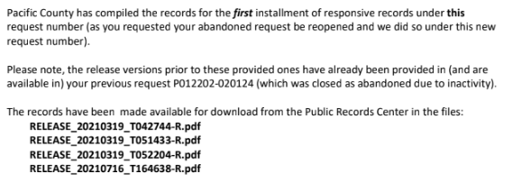

8/16/2024 2nd

